**Users :**

* A Salesforce user is someone who logs in. Users are personnel at your organization who require access to the company's records, such as sales representatives, managers, and IT professionals. Every Salesforce user has a user account.

**Creating A User :**

* Enter Users in the Quick Find box from Setup and select users.
* Click New User and enter the First Name as Class, Last Name as Teacher and (Your) email address and a unique username in the form of an email address. By default, the username is the same as the email address.
* Select a User License as salesforce.

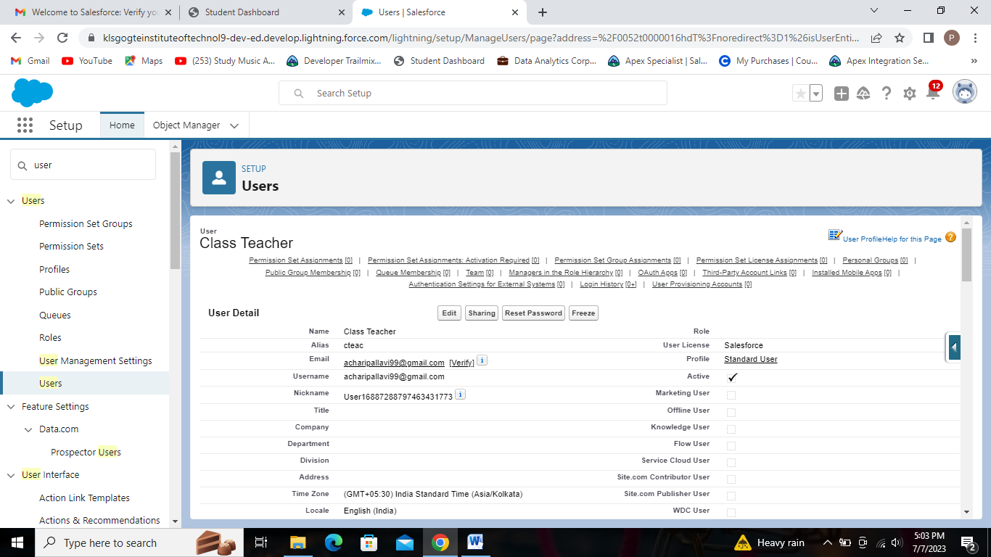

Creating user named ‘Class Teacher’.

**Creating Record Course Details Records :**

* Creating course Details record for course MBA.

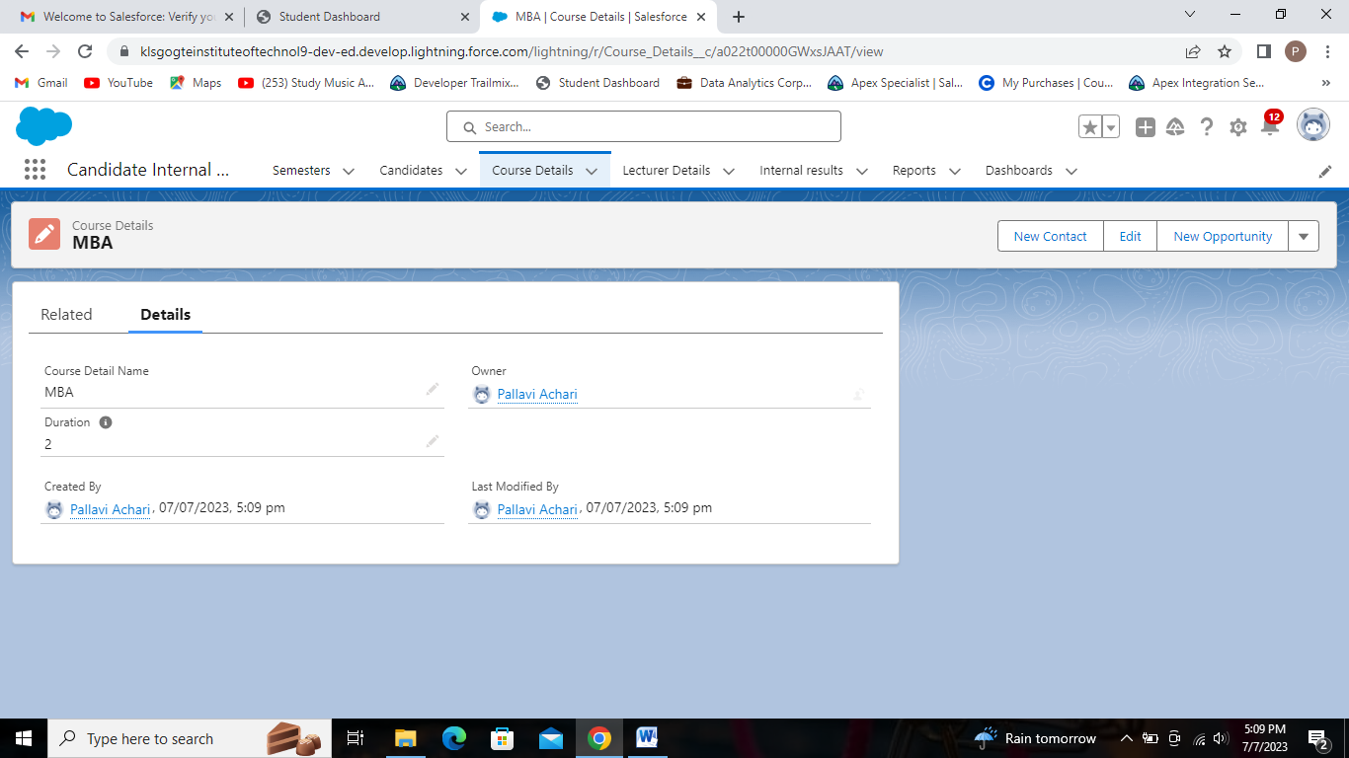

Record for MBA Course with duration 2 years.

* Creating course Details record for course MCA.

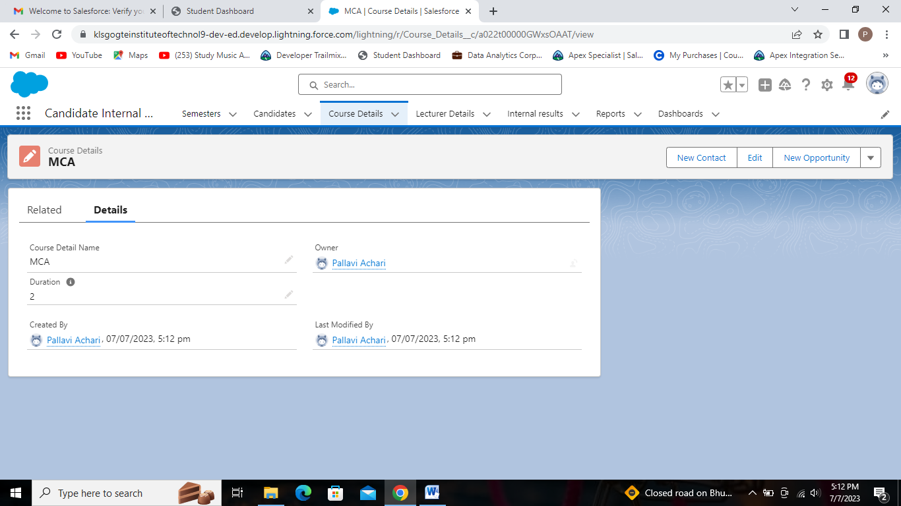

Record for MCA Course with duration 2 years.

* Creating course Details record for course BE.

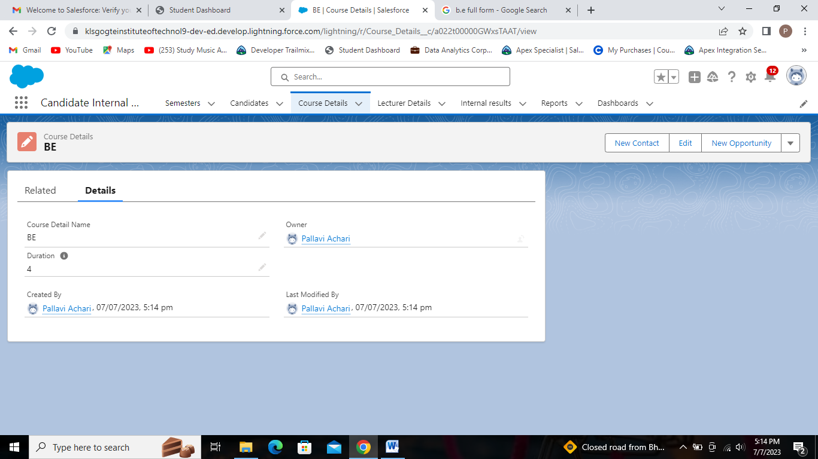

Record for BE Course with duration 4 years.

* Creating course Details record for course BTech.

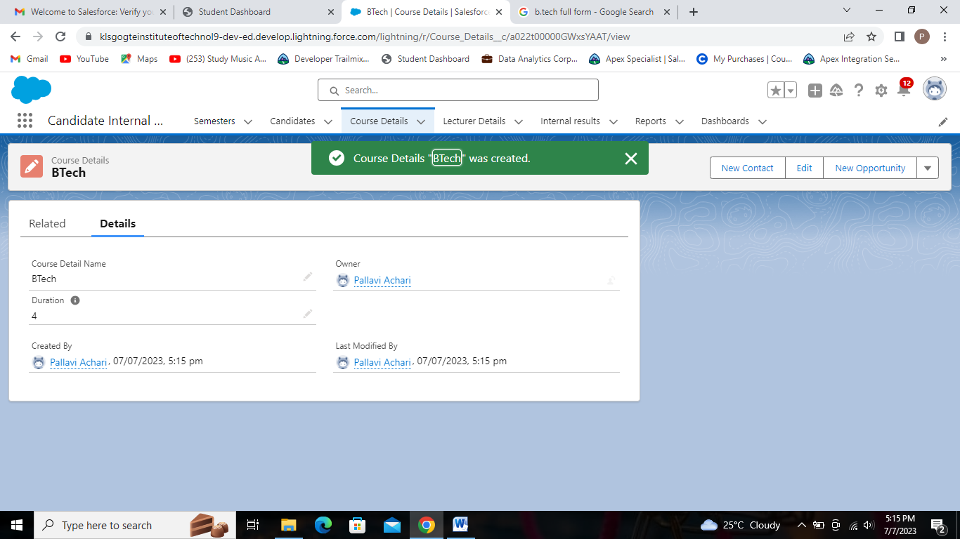

Record for BTech Course with duration 4 years.

* Creating course Details record for course BSc.

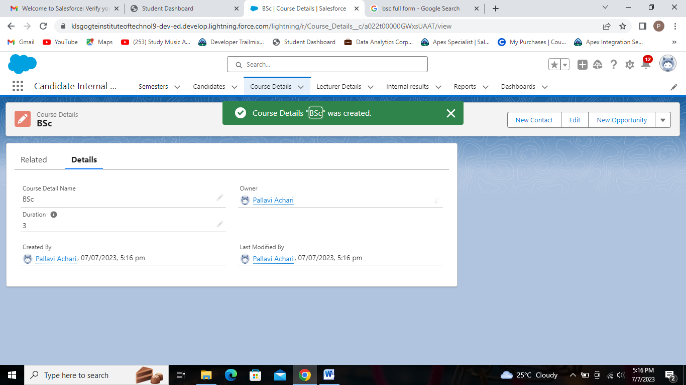

Record for BSc Course with duration 3 years.

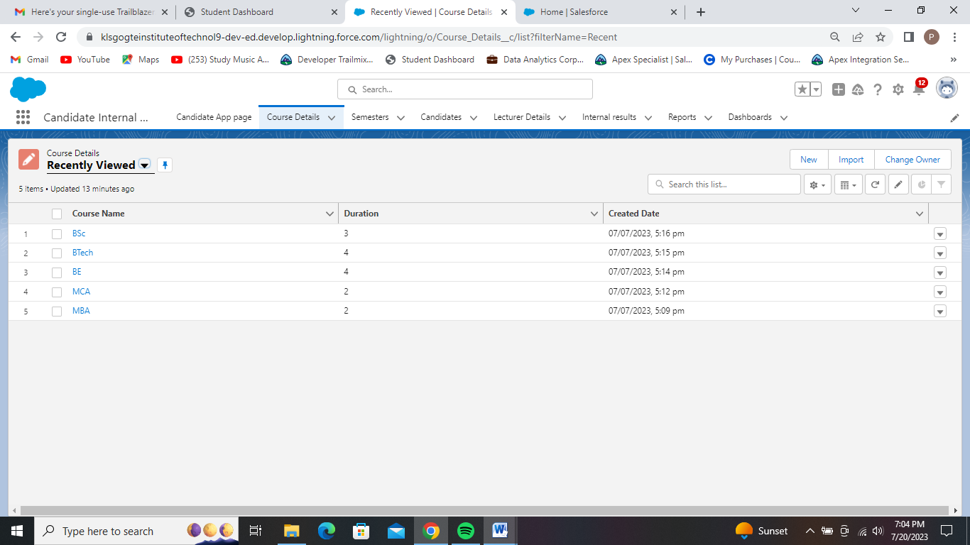

Course Detail Records of all five courses with duration.

**Creating Records for Semester Tab :**

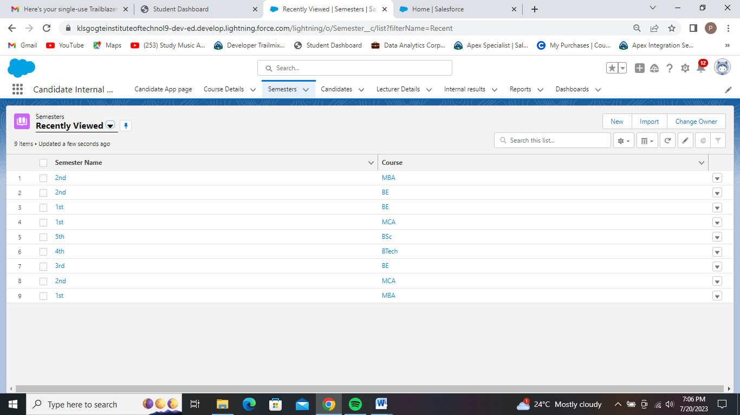

Semester Records with semester name and respected courses.

**Creating Records for Candidates Tab :**

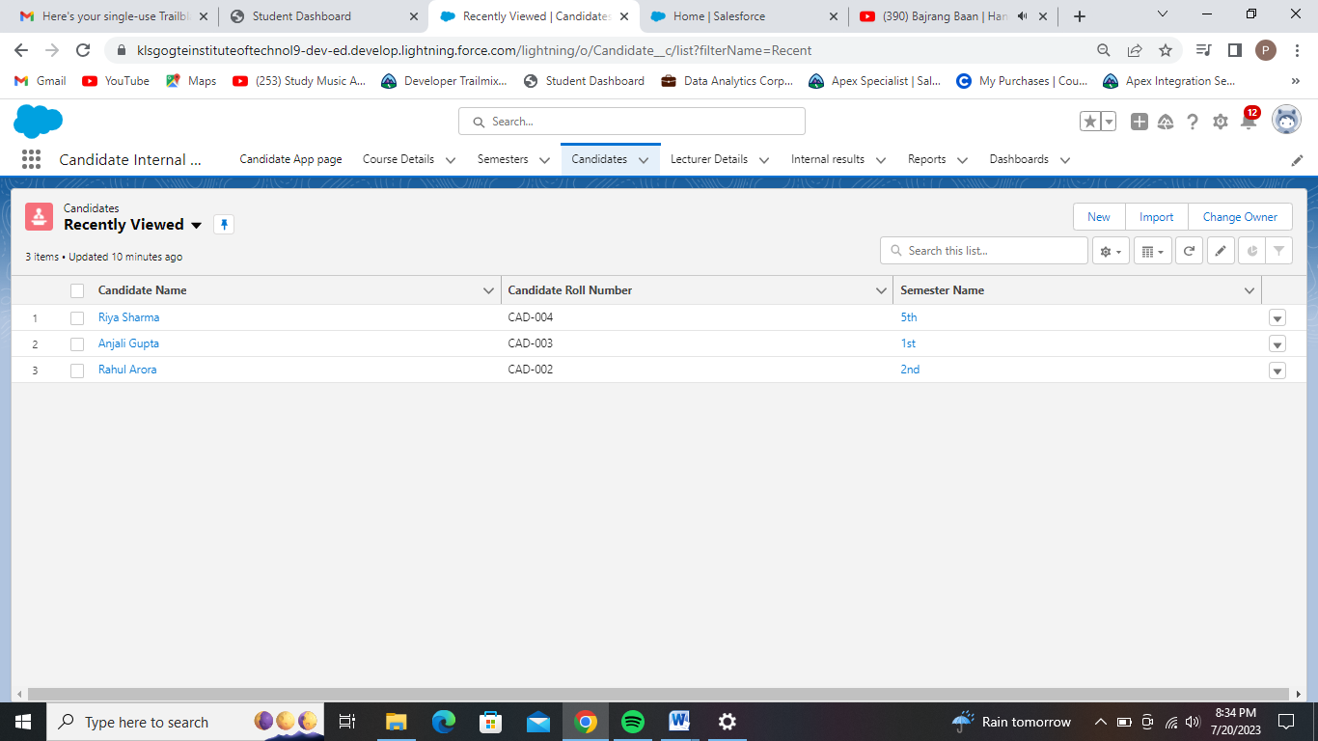

Records of Candidate Tab.

**Creating Records for Lecturer Details Tab :**

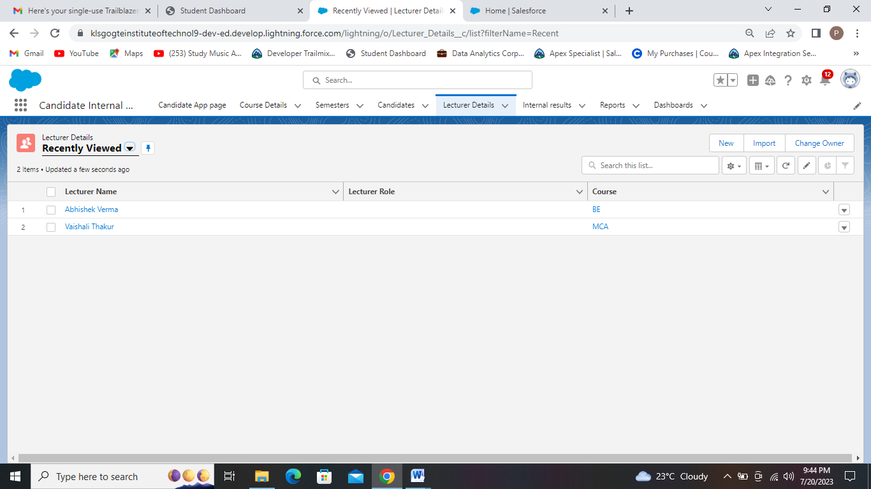

Records of Lecturer Details Tab.

**Creating Records for Internal results Tab :**

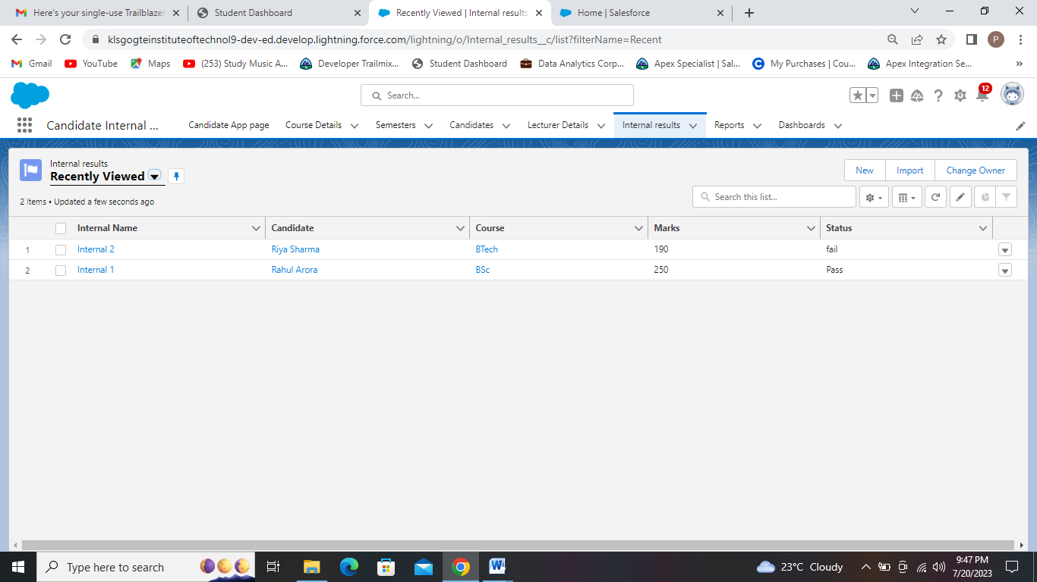

Records of Internal results Tab.